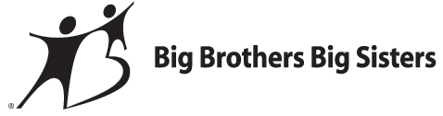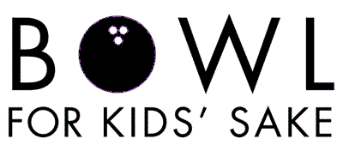

Date: Saturday, April 6, 2013

Place: Colonial Lanes, 3210 Wilmington Road, New Castle, PA 16105

Dear Bowl for Kids’ Sake Captain:

It’s time again for Bowl for Kids’ Sake! We are so glad you were able to join us! Bowl for Kids’ Sake, or BFKS, offers everyone in our community a chance to positively impact a child’s life. The children served by Big Brothers Big Sisters are among America’s most vulnerable, often living in a single parent household, growing up in poverty, or coping with parental incarceration. By participating in Bowl for Kids’ Sake, your team helps children reach their potential and, through them, transform families, schools, and communities.

To participate, each bowler commits to raising a minimum goal of $50.00. Everyone is invited and encouraged to go beyond the $50.00 goal by asking family and friends for sponsorships. Each bowling team can consist of 4-6 bowlers. Each team member will receive a free game of bowling, lunch, entertainment, and this year’s Bowl for Kids’ Sake t-shirt!

As in years past, we have gift cards available for those who reach specific fundraising goals, as well as, trophies for high male bowler, high female bowler, team challenge winner, and highest fundraiser.

As always, there will be plenty of ways to win! The lowest male and female scorer will each receive a “Golf Trophy.” Also, the top three bowlers in each time slot can bowl it out in the “Single Frame Showdown” for a $50.00 cash prize.

A Chinese auction will be held the day of the event. In previous years, prizes have included Vera Bradley bags, golf packages, gift certificates from local establishments, and much more. Be sure to check out the goodies on the day of the event!

Enclosed you will find sponsor sheets to give each team member, a prize list for different levels of money raised, and a team registration form to fill out and return to our office at your earliest convenience.

Thank you for helping us make this the most successful Bowl for Kids’ Sake yet!

Spare your time & Strike up a friendship!
Big Brothers Big Sisters of Lawrence County
Allisyn Wolfe &
Steve Landman
332 Highland Avenue
New Castle, PA 16101
(724) 657-3680

