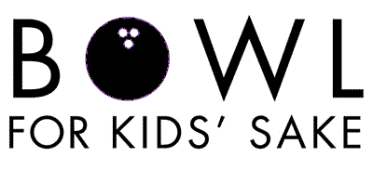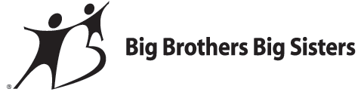

Become a Sponsor & Make a Difference.
Spare your time & Strike up a friendship!

Corporate/Group Lane Sponsor
- Level I: $150 Sponsor (Pays for an activity for 20 children on our waiting list)
  - Banner with your name and logo hanging over a lane
- Level II: $300 Sponsor (Supports 3 matches for one month)
  - T-shirt with name and logo on the back given to all participants
- Level III: $500 Sponsor (Covers transportation costs for High School Bigs for 1 school year)
  - Banner with your name and logo hanging over a lane
  - T-shirt with name and logo prominent spot)
- Level IV: $1,000 Sponsor (Provides match support for a community-based match for 10 months)
  - Banner with your name and logo hanging over a lane
  - T-shirt with your name and logo (prominent spot)
  - Be a featured sponsor in print materials and on the web

In-Kind Sponsor
- Donate a service for the day
- Donate a Chinese auction item
- Note: all donations are recognized in our program, at the event, on the web, and in the newsletter

Create a Bowling Team
- Teams consist of 4-6 bowlers
- Each bowling time slot is one hour
- Each team member commits to raising a minimum goal of $50.00 or more
- Bowling team members receive a free game of bowling, lunch, t-shirt & entertainment

Don’t have a team to bowl with? No problem!

We invite you to join us between the hours of 12 p.m. and 5 p.m. on April 6, 2013 at Colonial Lanes in New Castle. Enjoy a day of entertainment, door prizes, 50/50 raffle, and Chinese auction.
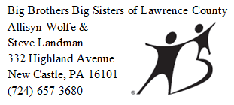By participating in Bowl for Kids’ Sake, you are helping the Lawrence County Big Brothers Big Sisters benefit the lives of children, and in return, benefit our community. For more information or to sign up a team, please contact:

