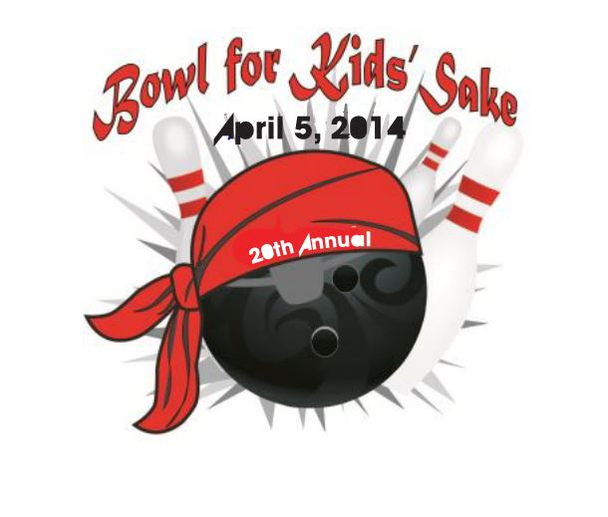

2014 Prize List
All bowlers are asked to raise $50 for the Bowl for Kids’ Sake event. Each bowler will receive a free game of bowling, lunch, entertainment, refreshments, a t-shirt, and a chance to win a door prize! Trophies will be awarded for the best scores and the most money pledged. Additional prizes will be awarded to those participants who reach the pledge amounts below.
The more pledges you get, the better your chances to reach one of these great prize levels! Take the opportunity to talk to friends, family, co-workers, neighbors, business partners, and more about this wonderful cause.

The top 3 Fundraisers in each time slot will participate in a “Single Frame Showdown” for a chance to win a CASH PRIZE!
Raise: Win:
$1,000 $200 Retail Gift Card
$700 $100 Retail Gift Card
$500 $75 Retail Gift Card
$250 $50 Retail Gift Card
$125 $20 Retail Gift Card
*Trophies will be awarded to the high male bowler, female bowler, team challenge winners and the person who raises the highest amount of money. In addition “golf trophies” will be given to the male and female bowlers with the lowest score.

