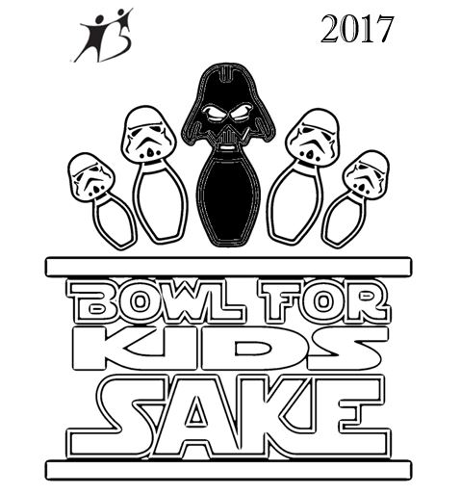
Event: Bowl for Kids’ Sake to benefit Big Brothers Big Sisters of Lawrence County

Date: Saturday, April 8, 2017

Place: Colonial Lanes, 3210 Wilmington Rd.

New Castle, PA 16105

Join fellow Jedi in a quest to make a positive difference in the lives of children in Lawrence County through Big Brothers Big Sisters!
It’s time again for Bowl for Kids’ Sake and this year, we’re celebrating Star Wars style! We are so glad you are able to join us. Bowl for Kids’ Sake offers everyone in our community a chance to positively impact a child’s life. The children served by Big Brothers Big Sisters are among America’s most vulnerable, often living in a single parent household, growing up in poverty, or coping with parental incarceration. By participating in Bowl for Kids’ Sake, your team helps children reach their potential by transforming families, schools, and communities.

In order to participate, each team member is asked to raise $50. Everyone is invited and encouraged to go beyond that goal, by asking family and friends for sponsorships. Bowlers, age 6-12, can bowl on your team for a $10.00 donation. Each bowling team can consist of 4-6 bowlers. All team member will receive a free game of bowling, lunch, entertainment, and this year’s Bowl for Kids’ Sake t-shirt!

Gift card prizes for those who reach specific fundraising goals, as well as, trophies for high male bowler, high female bowler, team challenge winner, and highest fundraiser. The top three fundraisers in each time slot will compete in the “Single Frame Showdown” for a $50.00 cash prize!

An auction will be held the day of the event. In previous years, prizes have included: Vera Bradley bags, golf packages, gift certificates from local establishments, and much more. Be sure to check out the goodies on the day of the event!

Enclosed you will find sponsor sheets for each team member, a prize list for fundraising efforts, and a team registration form. In order to guarantee your preferred timeslot and an event t-shirt, please register your team no later than March 22, 2017. Please bring your team’s funds raised to the event or your sponsors can visit www.CrayYouth.org to make a secure credit card donation (donors simply tap the “donate” icon, enter the amount that they are sponsoring you for, click “BFKS 2017” in the drop down menu under “programs, and enter your name where it says “dedicate my donation”).

If you have questions, please call Allisyn Wolfe at 724-654-5507.

Thank you for helping Big Brothers Big Sisters make this the most successful Bowl for Kids’ Sake yet!

